**PRESS RELEASE**

**COMMUNICATIONS AND MEDIA TEAM OF THE 2023 ASEAN SUMMIT**

**No.77/SP/TKM-ASEAN2023/ENG/5/2023**

**Aroma of Flores Coffee Draws Delegates of the 42nd ASEAN Summit in 2023**

**West Manggarai, 11 May 2023** – A number of tourist objects, including souvenir sales centers in Labuan Bajo, West Manggarai Regency, East Nusa Tenggara Province (NTT), were full of delegates and the organizing committee of the 42nd ASEAN Summit 2023 from various countries. The Super Premium Tourism City, located on Flores' westernmost point, is more active

There are no exceptions to the three points which are the locations for micro, small and medium enterprise (MSMEs) expo which are worth visiting according to the committee's recommendation, such as Gua Batu Cermin, Lapangan Waikusambi, and the Waterfront.

Reinhard Djo, the Head of Bank NTT's MSME Sub-Division and the Foster Village Festival, confirmed this on Thursday (11 May 2023).

Numerous guests began to visit the three locations and examine the assortment of prepared mementos and processed foods. Flores Coffee is one of these. Reinhard stated that dozens of foreign visitors relished the flavor of Flores coffee in the rows of MSME booths at Gua Batu Cermin.

According to Reinhard, the aroma and flavor of the extremely robust coffee served captivated the visitors.

Reinhard stated that a large number of visitors attended the ASEAN Summit 2023 Side Event Cultural Festival and sampled a variety of local snacks and foods

Labuan Bajo's 42nd ASEAN Summit 2023 had a positive impact on the local community. One of the economic effects is felt by native NTT coffee enthusiasts, particularly those who cultivate coffee on the Flores mainland

Observations on the fiel indicate that the ASEAN Summit delegates enjoyed authentic NTT coffee served at both the side events and the main events, which were presented by local NTT coffee entrepreneurs at the venue

It should be noted that NTT coffee is grown in multiple locations on the Flores, Sumba, Timor, and Alor mainlands. Approximately thirteen regencies are identified as coffee-producing regions whose quality and quantity are perpetually improved by the government in collaboration with numerous communities of NTT coffee enthusiasts.

Bony Romas, chairperson of the NTT Dekopi (Indonesian Coffee Council), remarked that Bajawa Arabica coffee, Manggarai Arabica, Robusta Manggarai, Yellow Caturra Manggarai, Red Bourbon Manggarai, and Juria Manggarai were among the most well-known and oldest varieties of NTT coffee

He stated that the Bajawa, Ngada Regency-grown Yellow Catura Bajawa is in high demand among local and international coffee connoisseurs due to its reputation as one of the finest beans

Similarly, the Juria Manggarai species originated in the Manggarai Regency village of Colol. This delectable old coffee has been maintained by the local community for generations. (Eko Budiono InfoPublik/TR/Elvira/SC)

***

For more information, please contact:

**Director General of Public Information and Communications of the Ministry of Communications and Informatics – Usman Kansong (0816785320).**

Get other information at <http://asean2023.id>, <https://infopublik.id/kategori/asean-2023>, and <https://indonesia.go.id/kategori/ragam-asean-2023>

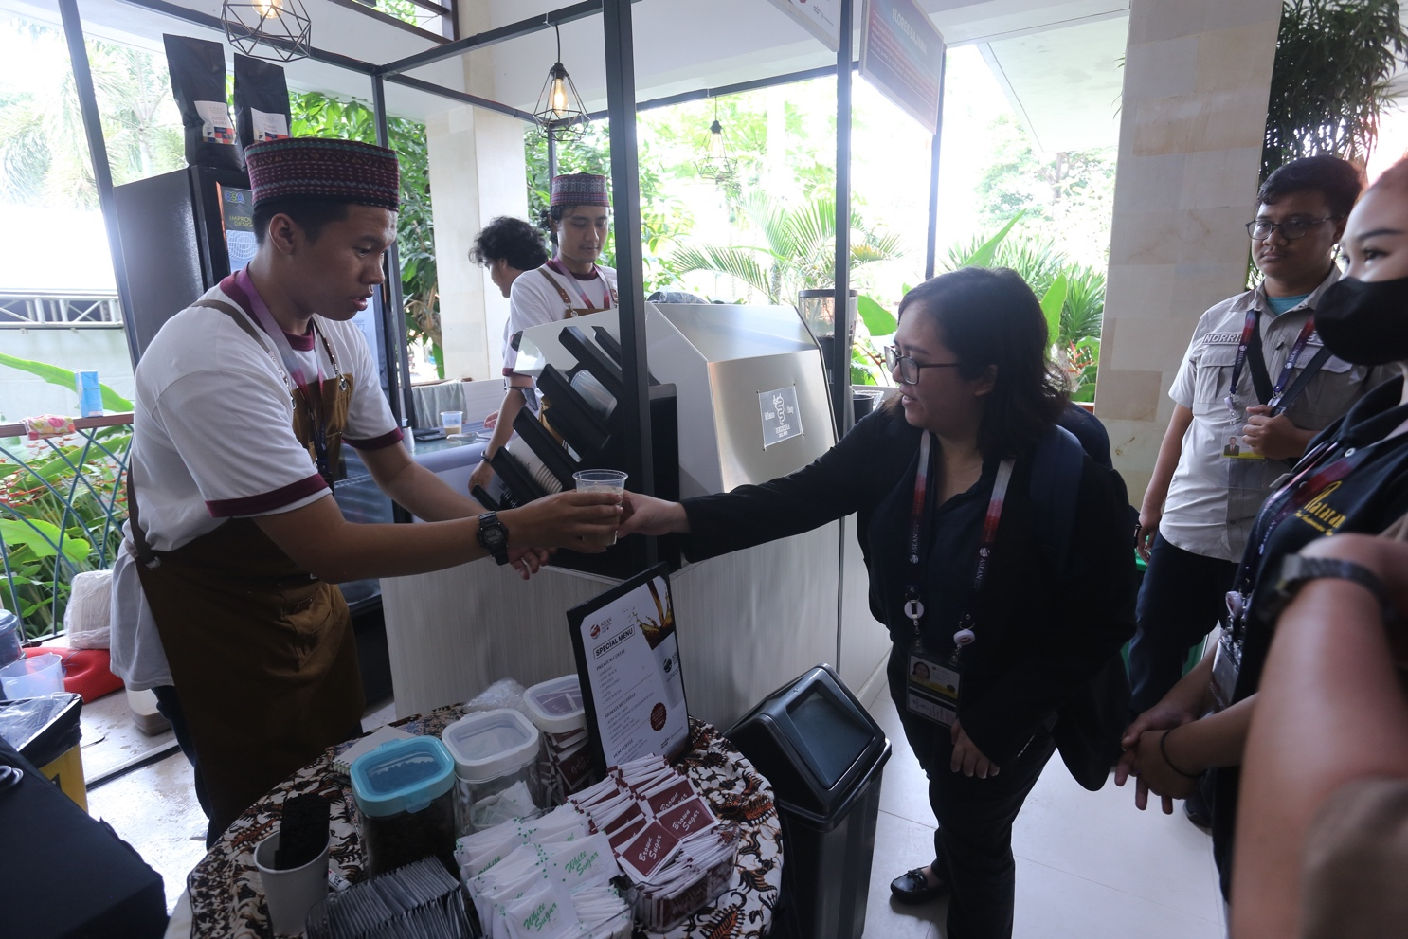

The delegates to the 42nd ASEAN Summit are enthusiastic about enjoying authentic NTT coffee served directly by local NTT coffee entrepreneurs at the venue, Thursday (11 May 2023).

